

Carbon PRO Report

Environmental Planting

Armidale, NSW

12March 2025

# Overview

The following is a property-specific assessment of select variables that are important to consider when assessing the feasibility of developing an [Environmental Planting (EP).](What%20is%20an%20Environmental%20Planting%20(EP))

You will be able to view fundamental information regarding the potential opportunity and obstacles to project development.

With a PRO and PRO+ subscription you will also have access to more elaborate information and interpretation of additional factors that are required for critical review in the decision-making process of your land assessment and project development.

## Summary of Assessment

|  |  |
| --- | --- |
| Project Name: | Armidale |
| **Location:** | Armidale, NSW |
| **Project Type:** | keep-icon-psychiatryEnvironmental Planting |
| **Project Area:** | 1804.0 ha |
| **Planting Area:** | 1213.2 ha |

Summary of key risks affecting a carbon projects feasibility.

Table . Summary of assessment

|  |  |
| --- | --- |
| Item assessed | Assessment |
| Planting Area | **Moderate risk.** More than 30% of the planting area is ineligible for environmental planting. |
| Carbon Returns | **High risk.** Only 4.1 ACCUs/ha. |
| Slope | **Low risk.** Little to no areas with slope greater than 15 degrees. |

## Planting Area (Overview)

This is the area that may be suitable for planting within your designated project area. As you can see on the map on the right with the ‘deforested’ overlay turned on, green polygons correspond to non-woody areas and pink polygons highlight regions likely to have been affected by forest dieback, clearing, or other forms of forest loss.

Table . Summary of the eligible planting area estimated by grovia using the National Forest and Sparse Woody Vegetation Data, 2023.

|  |  |  |
| --- | --- | --- |
| **Category** | **Total Area (ha)** | **Percent Cover (%)** |
| Project Area | 1804.0 | 100.00 |
| User Specified Exclusions | 41.2 | 2.28 |  |
| Other Exclusions | 549.6 | 30.47 |
| Total Eligible Planting Area | 1213.2 | 67.25 |

## Carbon Returns (Overview)

Carbon return, or the Estimated Project Value (EPV), is based on a 25-year crediting period. The EPV represents the potential financial and environmental benefits of an environmental planting project, primarily driven by the generation and sale of Australian Carbon Credit Units (ACCUs).

[Click here](Estimated%20Carbon%20Yield) for more information.

Table . Carbon returns

|  |  |
| --- | --- |
| **Metric** | **Value** |
| Property Planting Area | 1804.0 ha |
| Estimated Carbon Yield - Gross |  |
| * Project Total | 10,000 tCO2e |
| Estimated Carbon Yield - Net |  |
| * 25-year Permanence | 7,500 ACCUs |
| * 100-year Permanence | 9,500 ACCUs |

# Carbon

This section provides information that allows you to evaluate the carbon potential of your project area, assess eligibility with the Environmental Planting method and generate valuable insights for optimising project returns.

## Planting Area

The [Clean Energy Regulator (CER)](https://cer.gov.au/) sets specific eligibility requirements for the planting area in environmental planting projects under the Emissions Reduction Fund (ERF). These requirements ensure that projects contribute effectively to carbon sequestration and meet regulatory standards.

These requirements include ‘Land Use History’ (no recent deforestation) and ‘Exclusions and Ineligible Areas’ to prevent double-counting, environmental degradation, and conflicts with existing land uses.

Using the National Forest and Sparse Woody dataset, a two-stage process is used to estimate the planting area:

1. Assessment and removal of areas where land clearing has occurred within the project area in the last 7 years.
2. Calculating the total remaining area that is classified as ‘non-woody’.

Represented on the map on the right, approximately [x] hectares of the total property area, are classified as eligible for the establishment of an EP carbon project. Areas suspected of clearing constitute [x%] of the total property area.

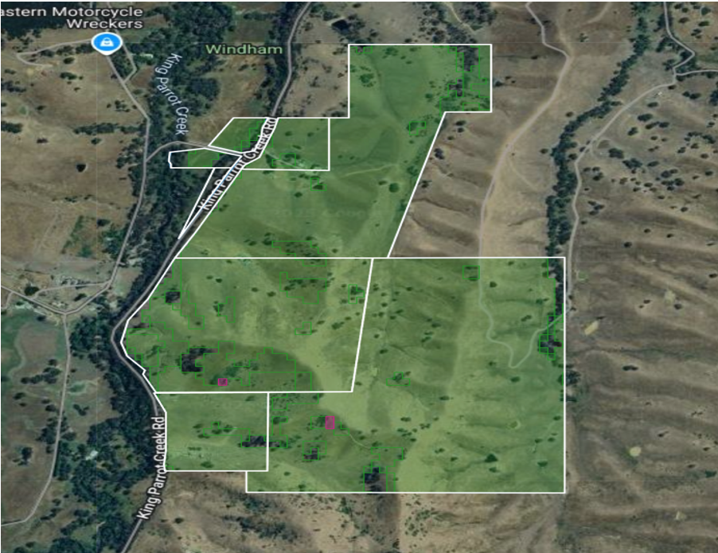

Figure . Boundary map of the project. Green polygons correspond to non-woody areas and pink polygons represent areas.

For more information on planting area, upgrade to a Carbon PRO assessment.

## Carbon Assessment

A preliminary carbon assessment indicated a potential return of [x] tCO2/ha/year, equivalent to approximately [x] Australian Carbon Credit Units (ACCUs) when considering the risk of reversal buffer for a project registered with a permanence period of 25 years.

### Spatial distribution of carbon yield

A carbon heatmap visually represents the distribution and capacity of the land to store aboveground carbon. This allows you to review and optimise your planting area based on the potential carbon yield.

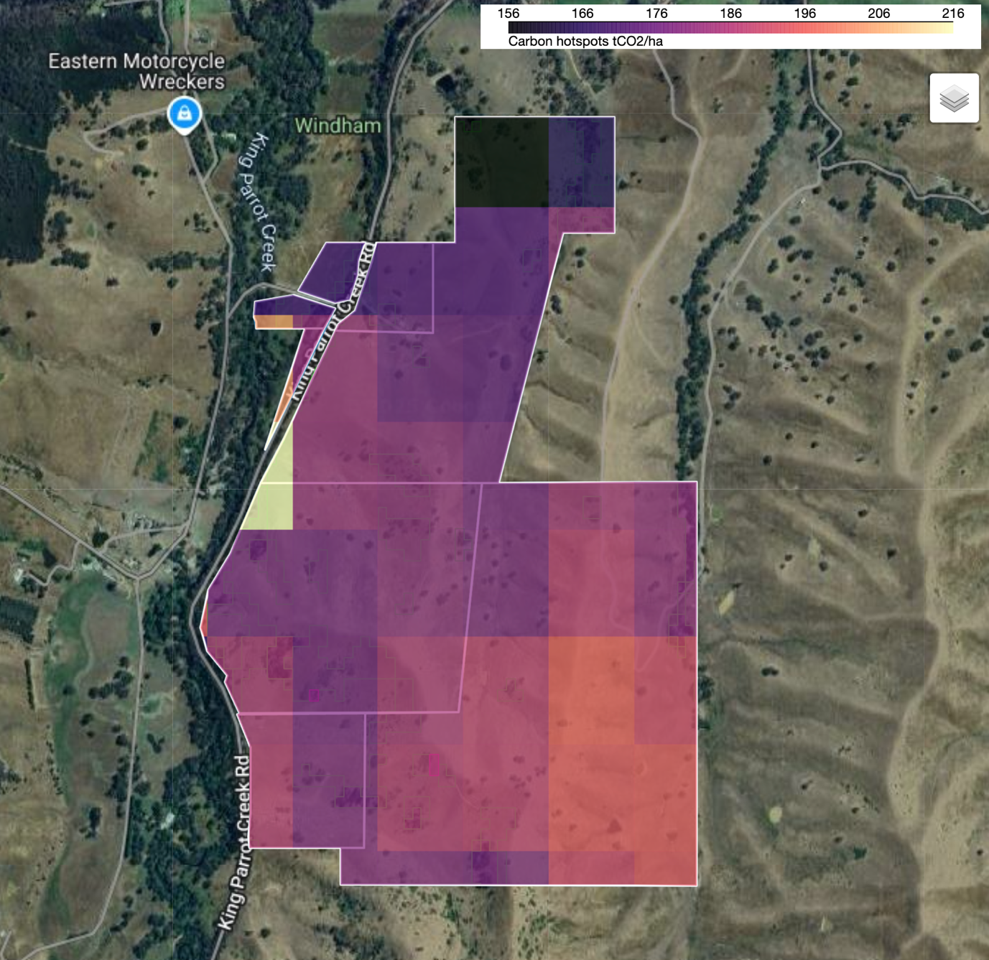

Figure . Spatial distribution of carbon potential across the property

### Carbon credits

A preliminary carbon assessment indicated a potential return of [insert value x] tCO2/ha/year, equivalent to approximately [insert value x] Australian Carbon Credit Units (ACCUs) when considering the risk of reversal buffer for a project registered with a permanence period of 25 years.

Table . Detailed breakdown of estimated Carbon Yield.

|  |  |
| --- | --- |
| **Metric** | **Value** |
| Project Planting Area | 1213.4 ha |
| Estimated Carbon Yield - Gross |  |
| * Project Total | 10,000 tCO2e |
| * per ha | 100 tCO2e |
| * per ha per year | 4 tCO2e |
| Estimated Carbon Yield - Net |  |
| * 25-year Permanence | 7,500 ACCUs |
| * 100-year Permanence | 9,500 ACCUs |

# Site information

To determine whether a site is suitable for a carbon sequestration project (such as environmental plantings under the Emissions Reduction Fund (ERF)), several factors must be assessed, including topography, infrastructure and land titles. Located within the xx NRM region.

## Slope

Slope is an important consideration for assessing EP carbon projects as it can directly influence future planting operations such as the operation of heavy machinery or by limiting accessibility. This section provides an overview of the topography of the specified project area.

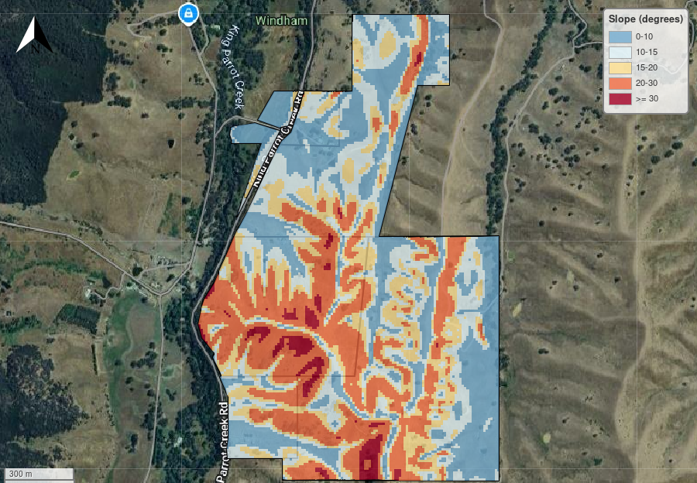

Figure . Slope across property

Table . Planting area defined by slope.

|  |  |  |
| --- | --- | --- |
| Slope (degrees) | Planting Area (ha) | Planting Area (%) |
| 0 - 10 | 46.51 | 28.14 |
| 10 - 15 | 38.28 | 23.16 |
| 15 - 20 | 32.59 | 19.71 |
| 20 - 30 | 43.63 | 26.39 |
| >= 30 | 4.30 | 2.60 |
| Total | 165.31 | 100.00 |

## Infrastructure

Transmission lines can present several risks to a carbon sequestration project, particularly environmental planting projects under the Emissions Reduction Fund (ERF). These risks can affect project eligibility, carbon credit generation, and long-term permanence obligations, eg if transmission line operators require land clearing for maintenance or upgrades, this could violate the permanence requirement, jeopardizing ACCUs already issued.

The map exclusion areas on the right will show if Transmission lines bisect the property.

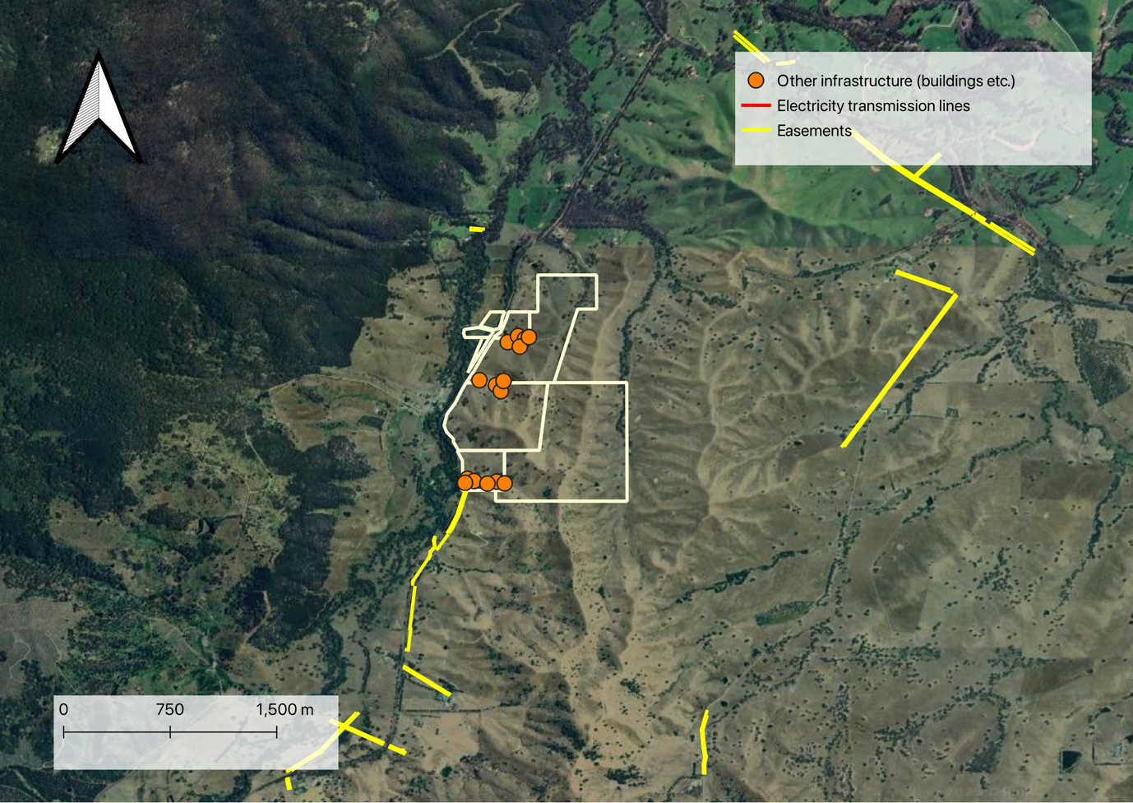

Figure . Infrastructure

## Tenure

Tenure is critical for carbon projects as it establishes legal ownership and land-use rights for the project site. Understanding the tenure type(s) of your project area is essential for determining project legitimacy, securing necessary permissions, and identifying key stakeholders involved in project development. Clear tenure ensures long-term stability and compliance, reducing risks to project success.

For information on tenure, upgrade to a Carbon PRO Assessment.

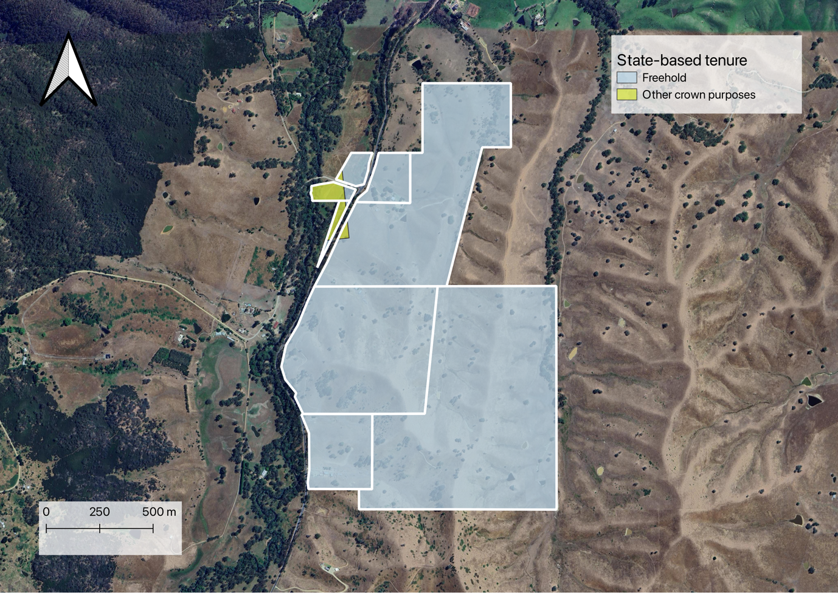

Figure . The tenure is Freehold with some conservation areas

## Zoning

Zoning dictates how land can be used, ensuring that projects align with legal and regulatory frameworks.If zoning laws don’t support conservation or reforestation, a project might fail verification and not generate credits.

For information on zoning, upgrade to a Carbon PRO Assessment.

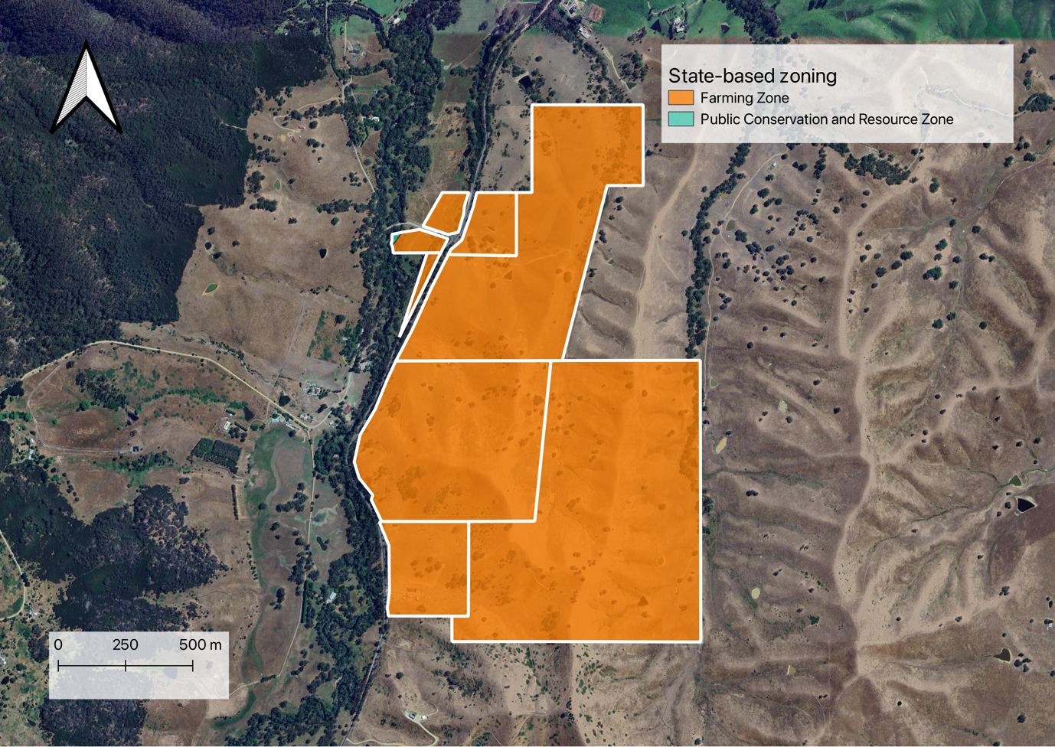

Figure . Zoning

## Land titles

A land title determines who has the right to sell carbon credits and receive financial benefits. Without a clear title, multiple parties might claim ownership, leading to disputes that can delay or invalidate a project.

### Native title

For information on native titles, upgrade to a Carbon PRO Assessment.

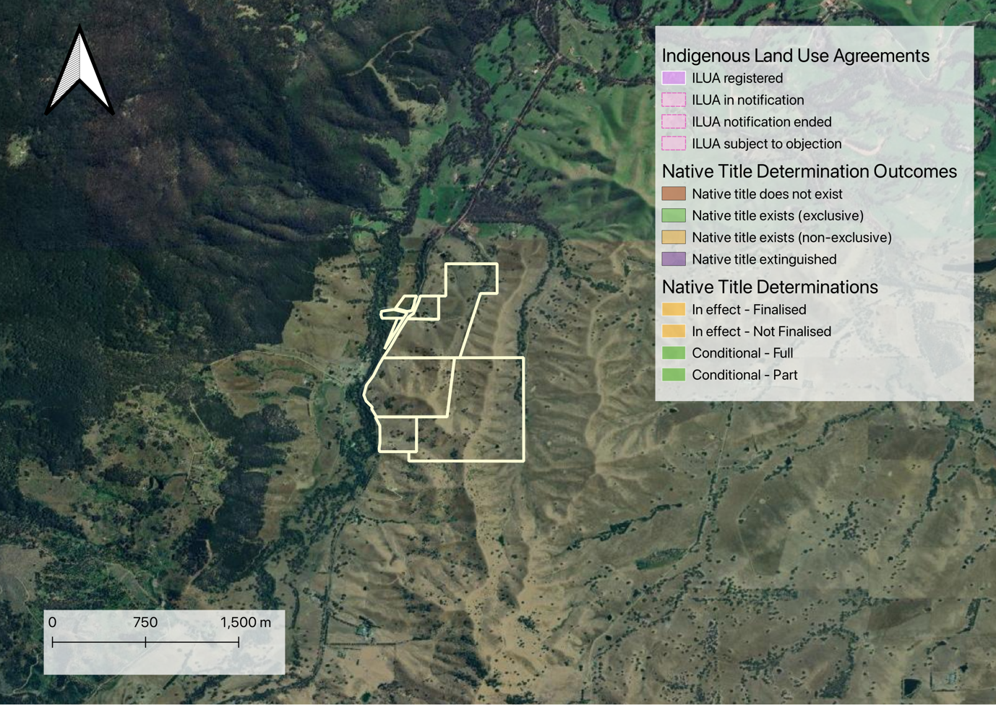

Figure . Native title

### Mining tenements and exploration licences

For information on mining tenements and exploration licences, upgrade to a Carbon PRO Assessment.



Figure . Mining tenements

## Existing CER projects

If an area is already covered by an existing CER project, there is a risk of double counting carbon credits which can lead to non-compliance with carbon standards and making credits invalid or reducing their market value. Similarly if an existing CER project is already addressing the same emission reductions, the new project might fail additionality tests and be ineligible for credits.

For information on existing CER projects, upgrade to a Carbon PRO Assessment.

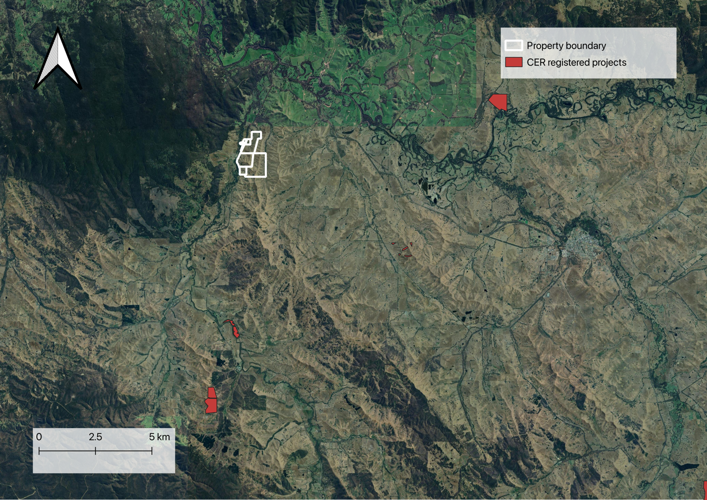

Figure . Existing CER registered projects

# Environmental

Carbon projects, particularly those involving environmental plantings, face various environmental risks that can affect their success, long-term viability, and ability to generate Australian Carbon Credit Units (ACCUs). These risks must be carefully assessed and managed to ensure project permanence and compliance with Emissions Reduction Fund (ERF) requirements.

## Climate

Climate and weather-related risks, eg rainfall and temperature, play a significant role in determining the success and long-term viability of carbon projects, particularly those focused on environmental plantings. These risks can affect carbon sequestration rates, project costs, and the ability to meet permanence obligations (25 or 100 years) under the Emissions Reduction Fund (ERF).

### Precipitation

Adequate rainfall is crucial for the growth and survival of vegetation used in carbon projects, especially in reforestation and revegetation efforts.

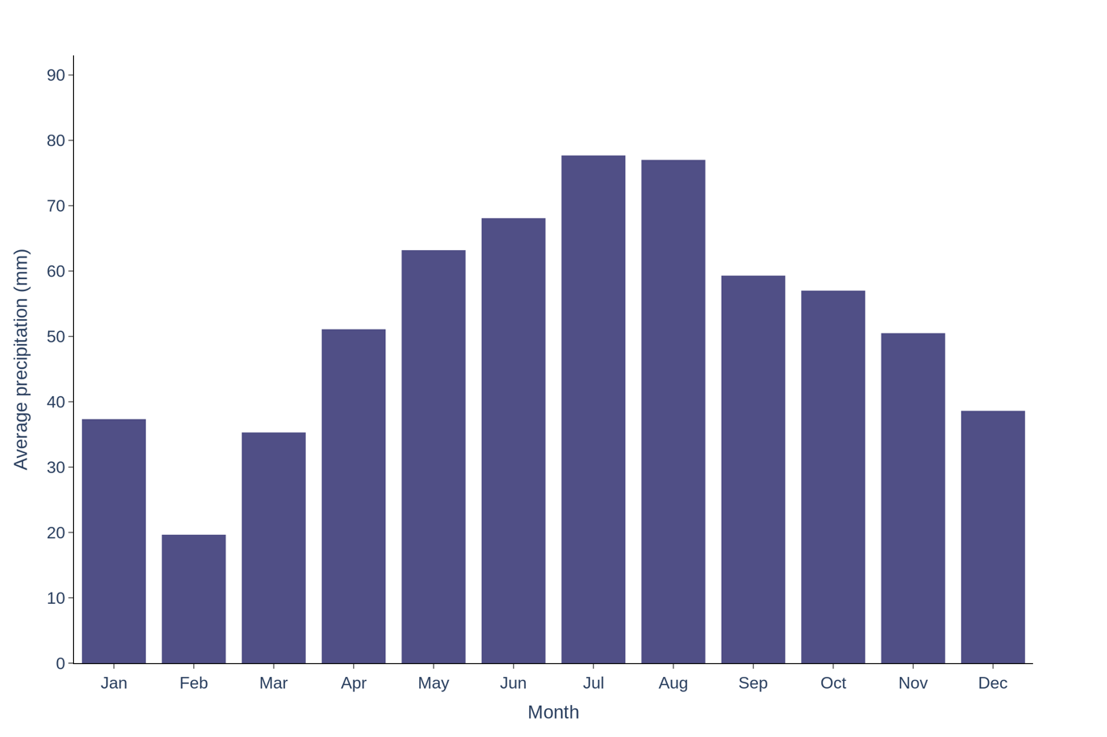

Figure . Precipitation

### Temperature

Temperature impacts suitable planting windows and directly affects the rate of photosynthesis in plants. Higher temperatures can increase the growth rates of vegetation, leading to faster carbon sequestration.

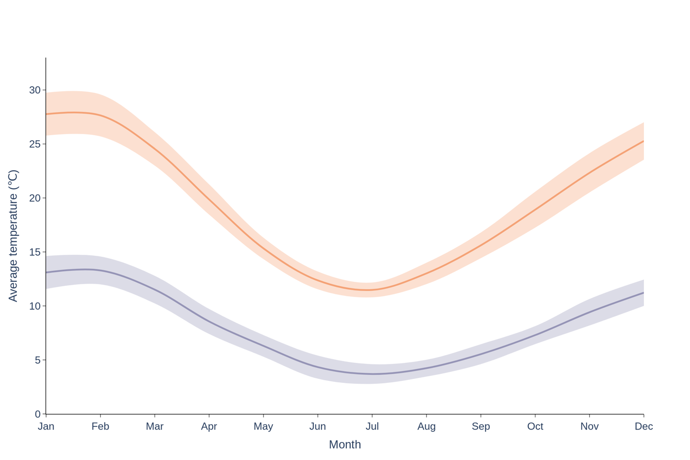

Figure . Temperature

### Frost

Frost tolerant plants may be required in your region.

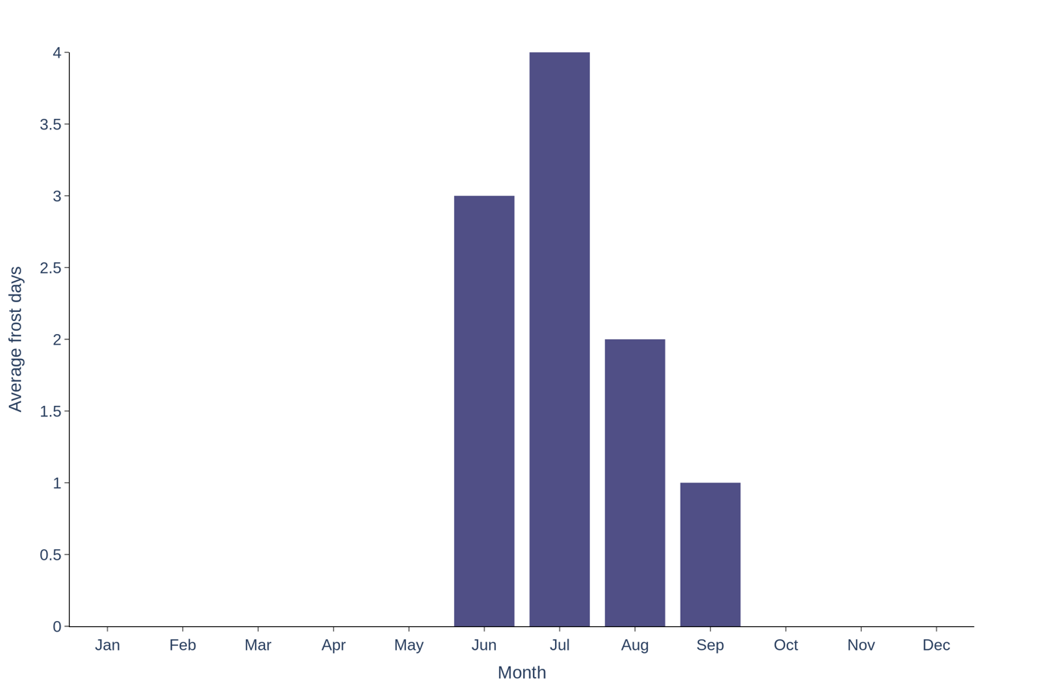

Figure . Frost

## Drought risk

Drought and reduced rainfall can significantly impact on carbon projects. For example, by degrading soil, increasing mortality of seedlings, slowing down tree growth - in turn all impacting sequestration rates, requiring replanting and increasing costs.

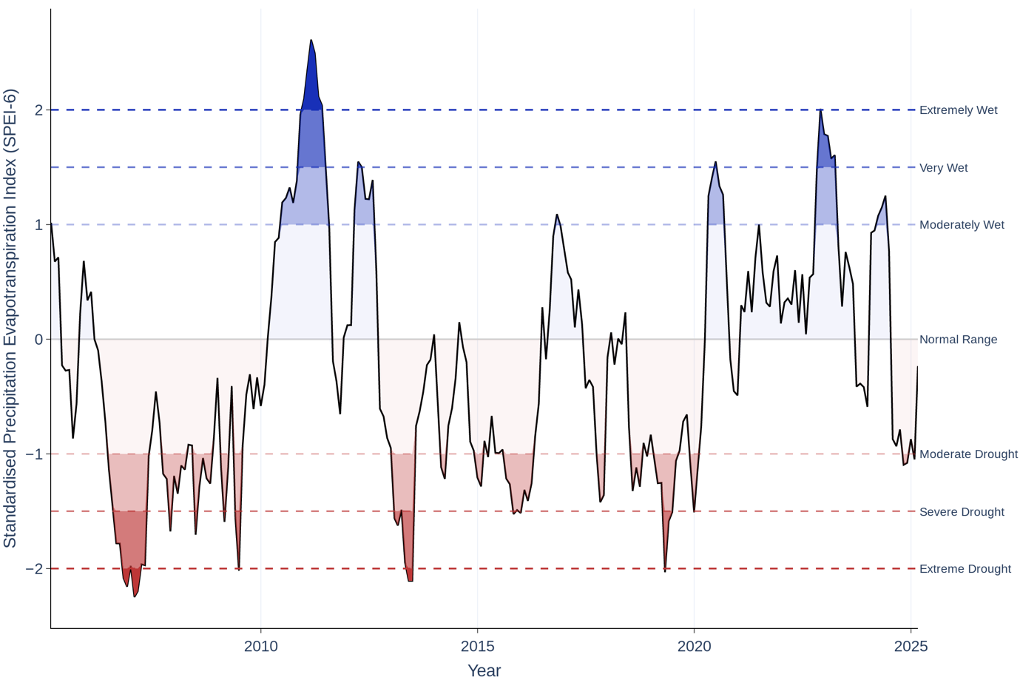

Figure . Standardised Precipitation Evapotranspiration Index (SPEI-6) over the last 20 years for the project site

## Bushfire risk

Increased fire risk threatens above-ground carbon storage. The ‘historic bushfire’ overlay on the right shows bushfires that have occurred in the area 50km radius of the property since 1906.

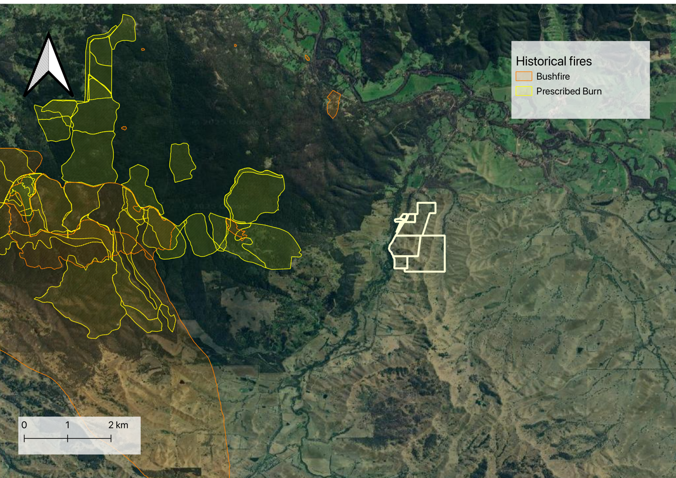

Figure . Bushfires in the region

## Flood risk

Flooding & Heavy Rainfall Events impacts on carbon projects through causing erosion & soil loss, damage to seedlings and plant roots, which may kill plants and slow sequestration, increasing replanting costs.

The ‘flood hazard’ overlay on the right visualises areas of the property that are at risk of flooding.

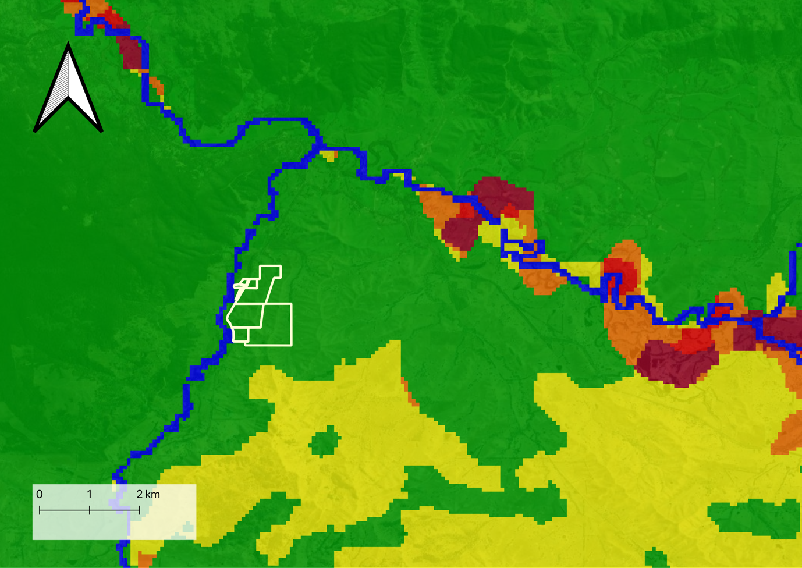

Figure . Flood risk in the region

## Salinity

Salinity, or the concentration of salt in soil and water, can significantly influence the success and carbon sequestration potential of environmental projects, where high salinity can be a major constraint on plant growth and soil health, making it a critical factor to consider in carbon project design and management.

### Dryland salinity

The ‘dryland salinity’ overlay on the right shows whether there is a risk of having high salinity.

Dryland salinity refers to the accumulation of salts in the soil of non-coastal (dryland) areas, which primarily affects agricultural lands, natural ecosystems, and water quality. It occurs in areas with low rainfall and can result from both natural processes and human activities, often exacerbated by land use changes such as agriculture and deforestation.

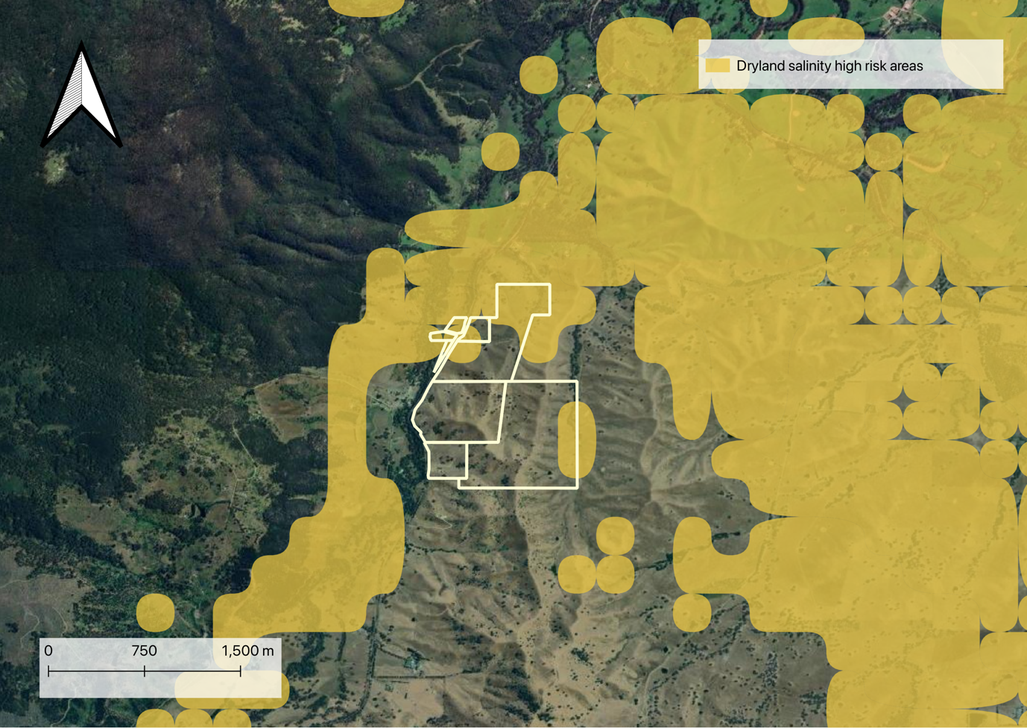

Figure . Areas deemed high risks of dryland salinity in the area

### Surface salinity

For more information on surface salinity, upgrade to a Carbon PRO report

# Biogeography

In the context of carbon projects, biogeography plays a crucial role in determining suitable locations, vegetation types, and carbon sequestration potential for environmental plantings.

## Vegetation

### Major vegetation groups (pre-European settlement)

Australia's vegetation is classified into Major Vegetation Groups (MVGs) at a national scale based on dominant plant communities, climate, and ecological characteristics. These classifications help in determining the potential yield for carbon sequestration projects. For instance, Forests & Woodlands (Eucalypt, Acacia, Casuarina) have high carbon sequestration potential, whereas Grasslands & Shrublands (Spinifex, Saltbush) are often less viable for ACCU projects unless revegetation is planned.

The map overlay ‘Major Vegetation Groups’ highlights the vegetation classification for the property.

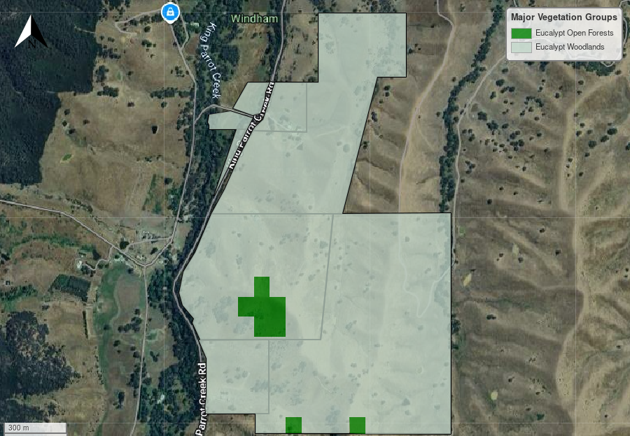

Figure . Major Vegetation Groups (MVG)

### State-based vegetation mapping (pre-European settlement)

For information on detailed state-based vegetation mapping, upgrade to a Carbon PRO report

## Soil

Soil is fundamental to the success of any restoration project, directly impacting plant establishment and long-term survival. Understanding soil characteristics helps identify risks early and informs key actions such as targeted soil testing, land remediation, and site preparation. A well-informed soil assessment ensures a strong foundation for restoration success.

For more information on soils, upgrade to a Carbon PRO report

## Potential Weeds

Weeds present a major threat to both the farming industry and Australia’s natural environment, with problematic species varying by region. Identifying key weeds in your project area enables targeted ecological assessments, helps gauge their potential impact on project success, and informs cost-effective management strategies. Early detection and proactive control are essential to ensuring a compliant, resilient, and high-quality carbon project.

For more information on potential weeds, upgrade to a Carbon PRO report

# Next steps

## Summary

If a project is deemed feasible and worth developing further, the next steps are summarised in figure 18 below:

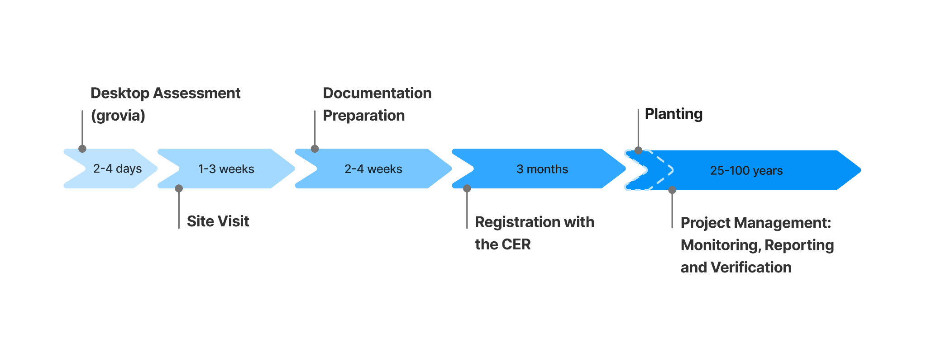

Figure . A timeline outlining the key stages of a carbon project, from initial desktop assessment and site visits to CER project registration and ongoing monitoring, reporting, and verification post-planting.

## Considerations

Evaluating the feasibility of an EP project requires the analysis of additional factors that may influence project development. For example, environmental conditions such as soil type, vegetation classifications, long-term climatic conditions, and exposure to natural hazards can significantly influence the overall viability of developing a biodiverse planting, and ultimately determines whether a property is suitable to progress.

Project proponents[1] are also required to assess additional risks such as whether there is a legal right to develop a project by considering variables such as land tenure, zoning, native title claims and how regional and local strategic plans may impede project establishment.

It is also beneficial for project proponents to have a high degree of confidence that the carbon sequestration potential of a project is accurate. For EP carbon projects, this requires a method-compliant workflow of project stratification, followed by modelling the projects potential ACCU generation through the Full Carbon Accounting Model (FullCAM) software[2].

## Next steps

### What else is involved with an EP project?

After a desktop assessment, a site visit is highly recommended as it offers the opportunity to ground-truth the information gathered in this report and to also reassess how these variables meet (or do not meet) project eligibility requirements. For example, information from a site visit will likely inform the recalculation of the potential ACCUs generated from a project by refining the planting and exclusion areas.

### Proceeding with the carbon project

The grovia platform is designed to help you streamline the steps outlined in figure 18; from further assessing the feasibility of a project with site visit data, to optimising planting efforts and fine-scale tracking of project success with our measurement, reporting, and verification (MRV) data management module.

As a next step, chatting to the team about refining your planting area based on a site visit.

Our expert team will work with you to understand all your project goals and ensure the project is delivered to a high standard and with integrity. If you would like to request a report, or have any questions, please get in touch *contact@grovia.earth*. 

1. A project proponent is the party who has the legal right to develop a project and is responsible for carrying out the project, is issued credits for the project and is legally responsible for meeting all obligations under the law. See<https://cer.gov.au/schemes/australian-carbon-credit-unit-scheme/how-to-participate/plan-your-project/choose-project-proponent> for more information.
2. <https://www.dcceew.gov.au/climate-change/publications/full-carbon-accounting-model-fullcam>